VS Code Extensions

**Bookmarks**

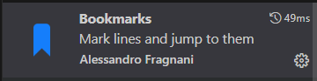

**Material Icon Theme**

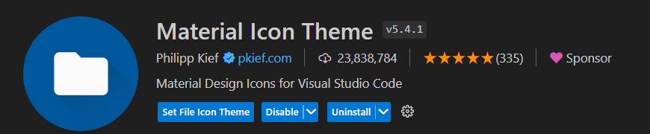

**Auto Rename Tag**

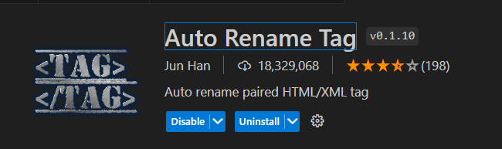

**Bootstrap IntelliSense**

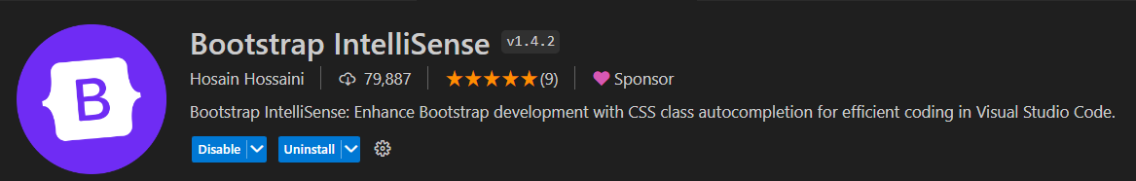

**Bracket Pair Color DLW**

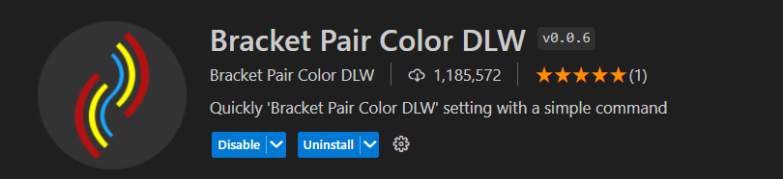

**Bracket Select**

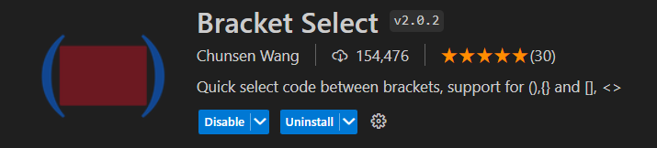

**Code Runner**

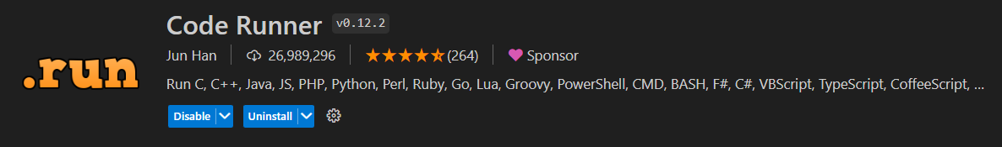

**Code Spell Checker**

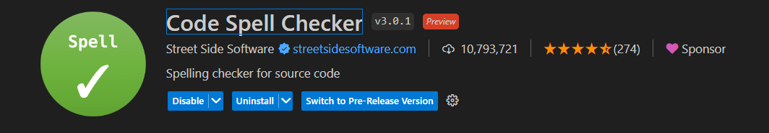

**Codeium: AI Coding Autocomplete and Chat for Python, Javascript, Typescript, Java, Go, and more**

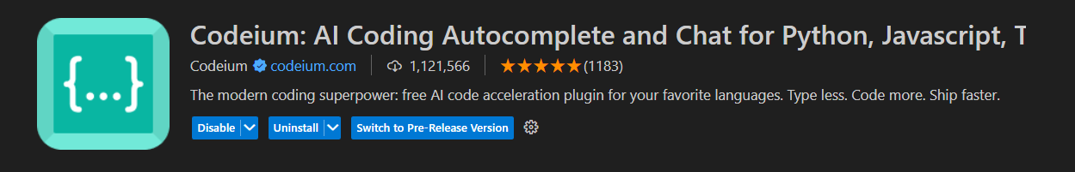

**CodeSnap**

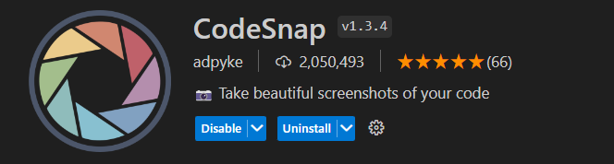

**CSS Peek**

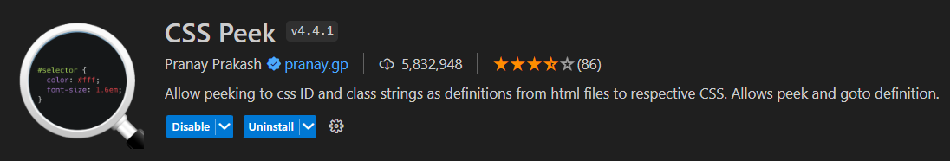

**Customize Toolbar**

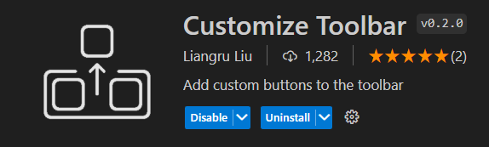

**Docs View**

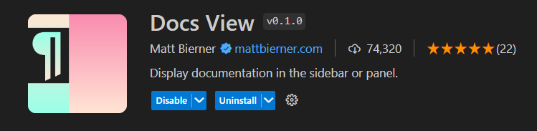

**Emmet Keybindings**

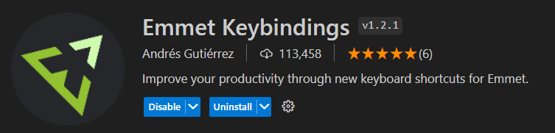

**Error Lens**

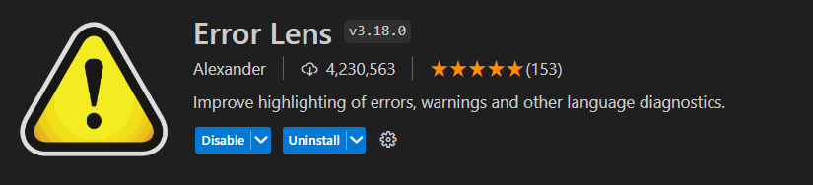

**ES7+ React/Redux/React-Native snippets**

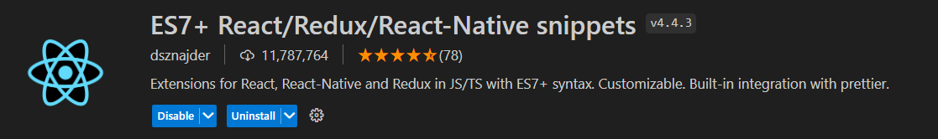

**GitLens — Git supercharged**

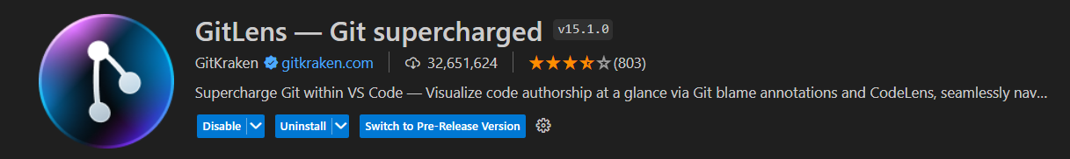

**indent-rainbow**

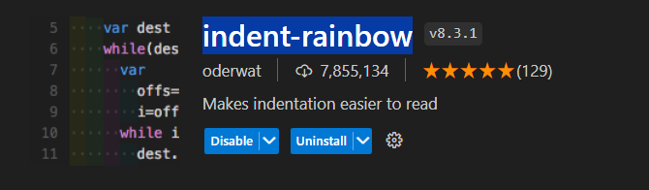

**Live Server**

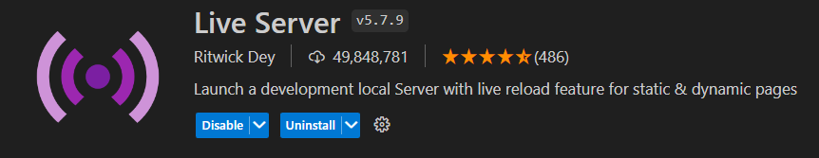

**Path Intellisense**

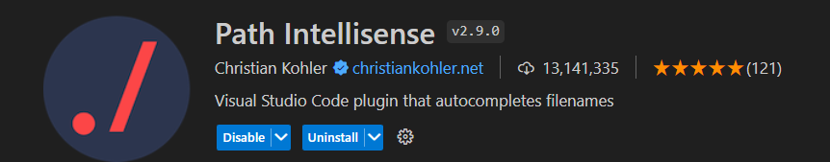

**Peacock**

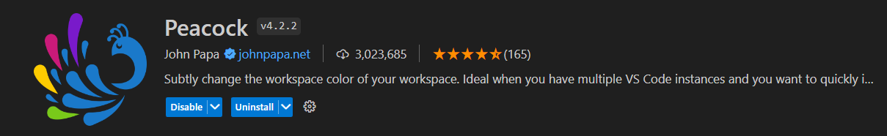

**Prettier - Code formatter**

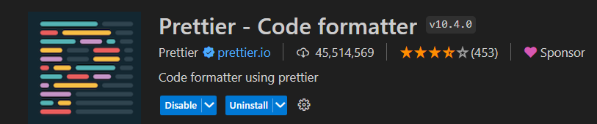

**Pretty TypeScript Errors**

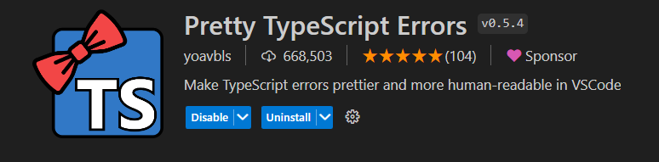

**Rainbow CSV**

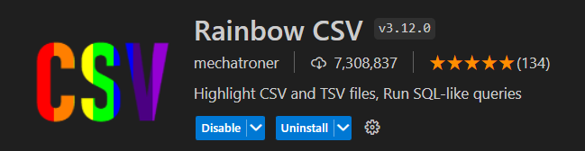

**Rainglow**

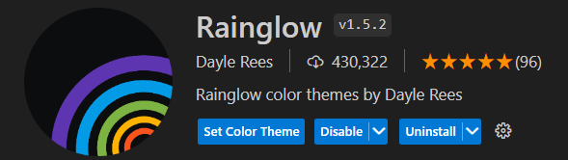

**Relative Path**

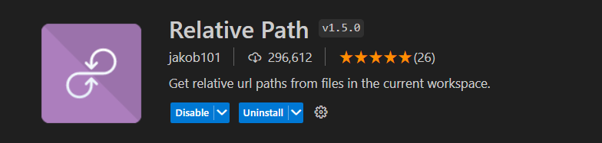

**Shortcuts**

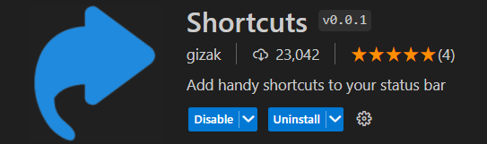

**Sort Lines by Selection**

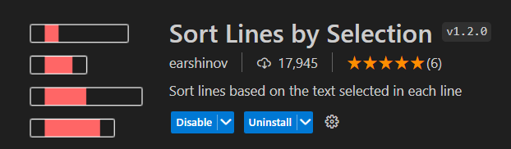

**Staticfile CDN**

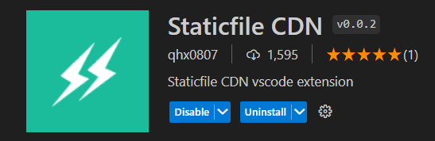

**Surround with Tag**

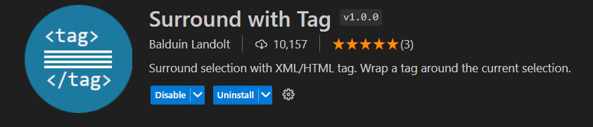

**Swap Selections Text**

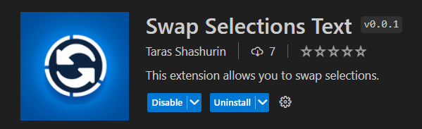

**Tailwind CSS IntelliSense**

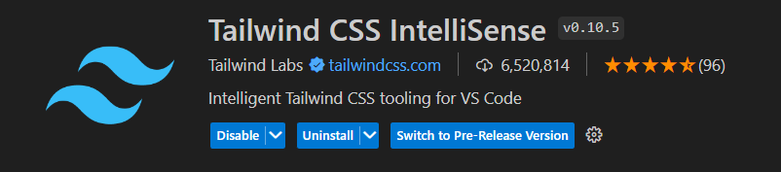

**Thunder Client**

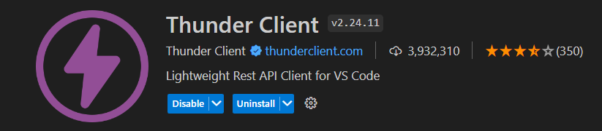

**Total TypeScript**

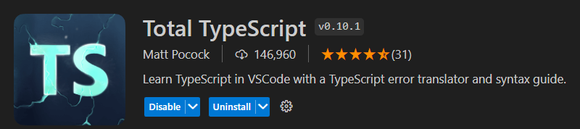

**Version Lens**

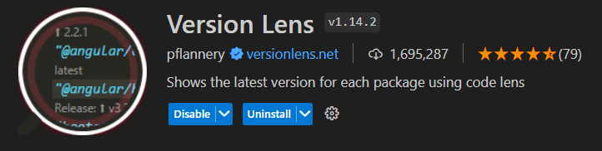

**Draw.io Integration**

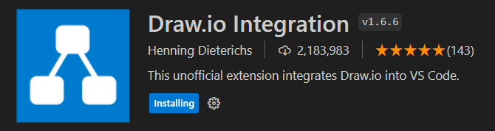

Add into settings.json

"CustomizeToolbar.buttonConfig": [

        {

            "name": "Go to Matching Pair",

            "icon": "code",

            "command_vscode": "editor.emmet.action.matchTag",

        },

        {

            "name": "Remove Html Tag",

            "icon": "remove",

            "command_vscode": "editor.emmet.action.removeTag"

        },

        {

            "name": "Wrap with Abbreviation",

            "icon": "symbol-parameter",

            "command_vscode": "editor.emmet.action.wrapWithAbbreviation"

        },

        {

            "name": "Select Tag",

            "icon": "selection",

            "command_vscode": "editor.emmet.action.balanceOut"

        },

        {

            "name": "Inward Html Tag Select",

            "icon": "symbol-keyword",

            "command_vscode": "editor.emmet.action.balanceIn"

        },

        {

            "name": "Inside Content Select",

            "icon": "symbol-array",

            "command_vscode": "bracket-select.select-include"

        },

        {

            "name": "Select to Bracket",

            "icon": "symbol-package",

            "command_vscode": "editor.action.selectToBracket"

        },

    ],

Add into settings.json

"shortcuts.buttons": [

        "refresh , workbench.action.reloadWindow , Reload Window",

        "telescope , workbench.action.showCommands , Show command palette",

        "bug, workbench.action.debug.start, Launch debug",

    ],

**Case Change**

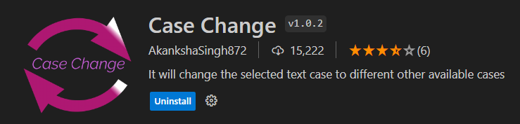

**Commands**

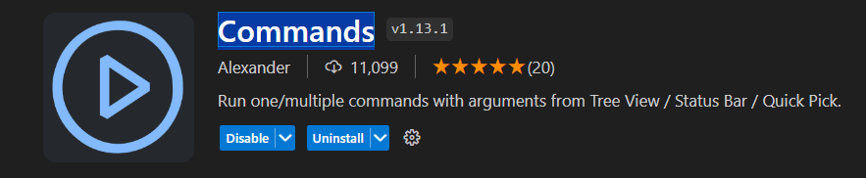

**VSCode Animations**

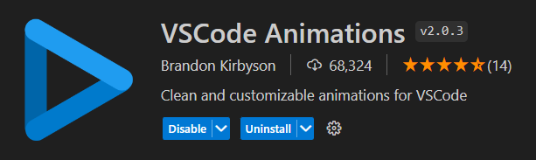

**Apc Customize UI++**

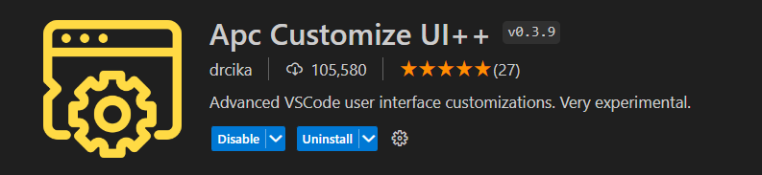

**Custom CSS and JS Loader**

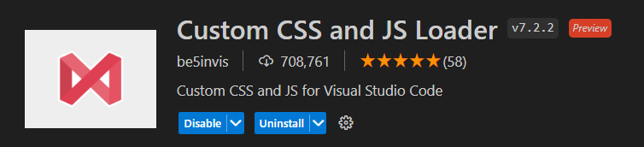

**SpaceBox UI Enhancer**

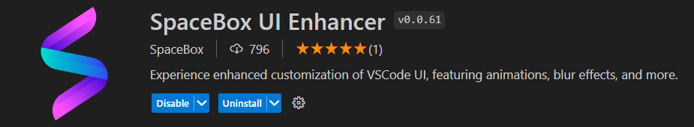

**Source Code Visualizer**

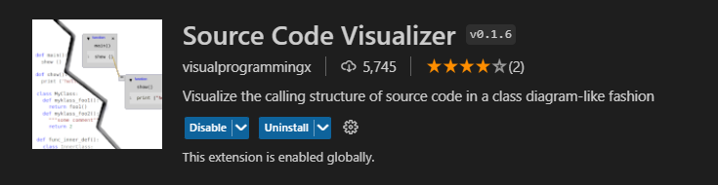

**SVG**

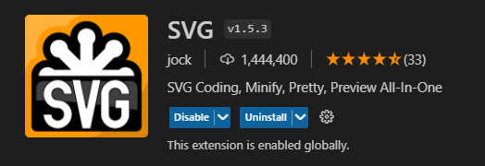

**WSL**

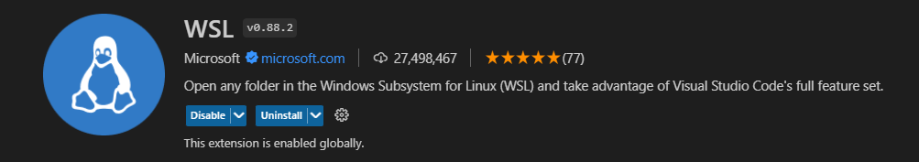

**REST Client**

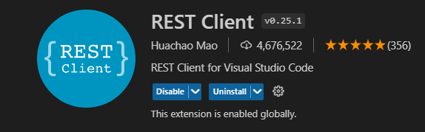

**Live Preview**

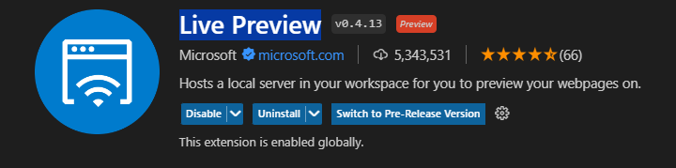

**Auto Import**

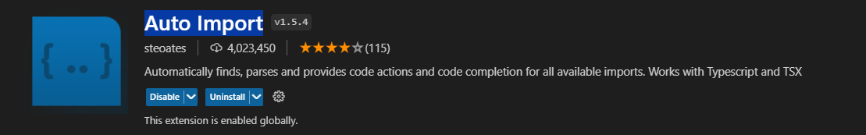

**JSON Crack**



**Quick Select**

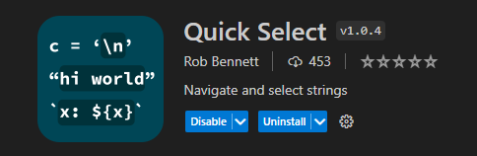

**CDNJS**

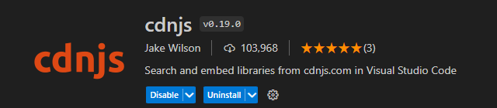

**Twoslash Query Comments**

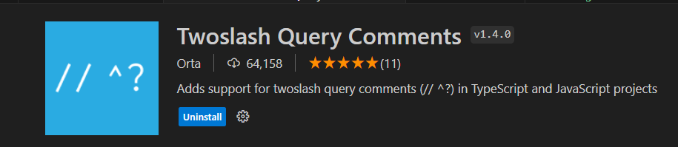

**Inline Fold  
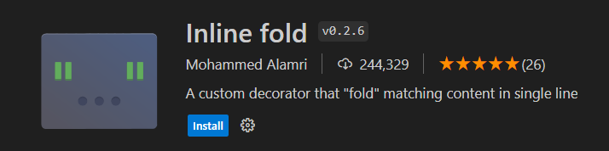**

**Blur Menu**

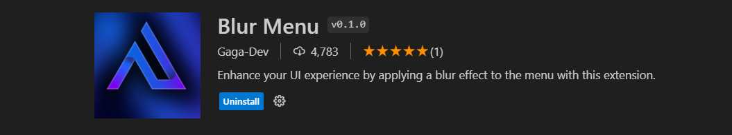

**Single-line, Multi-line**

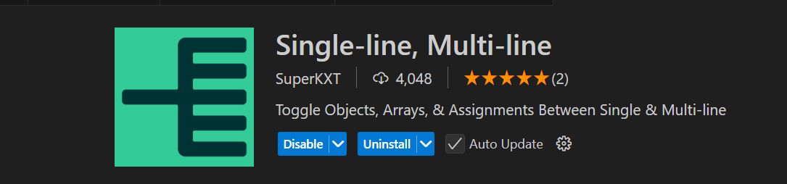

**multi-command**

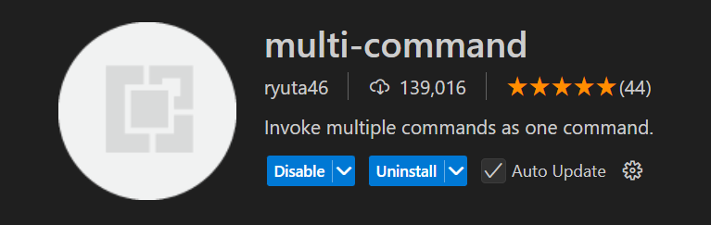

**Git Graph**

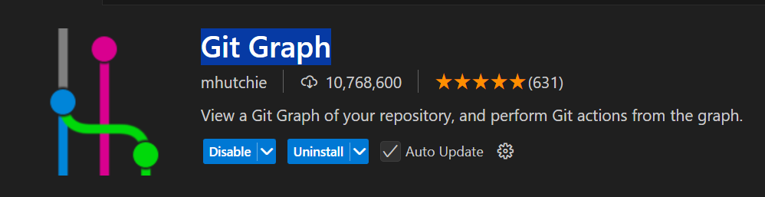

**DotENV**

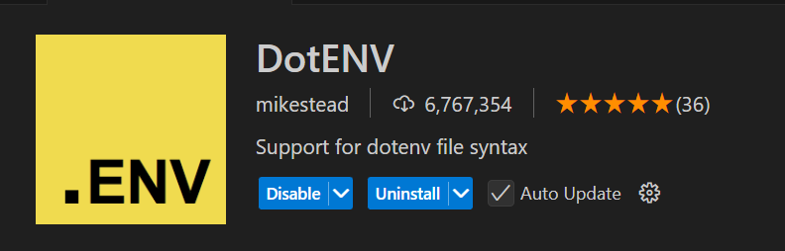

**vscode-icons**

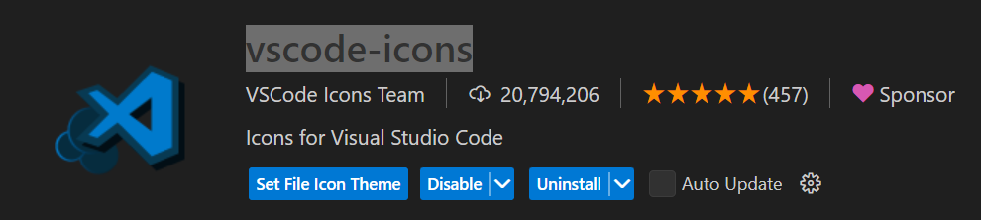

**HTML End Tag Labels**

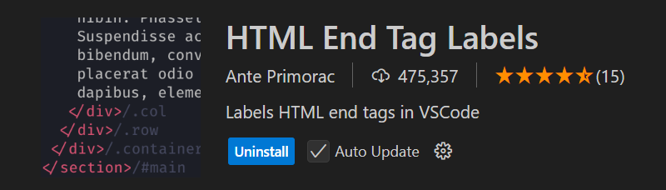

**html to JSX**

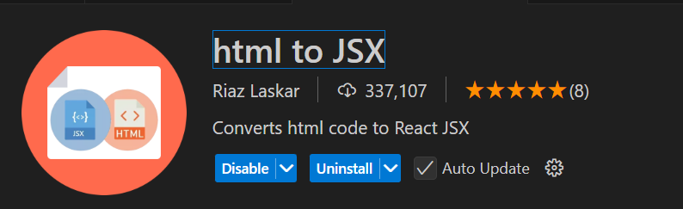

**Split HTML Attributes (Vue, React, Angular)**

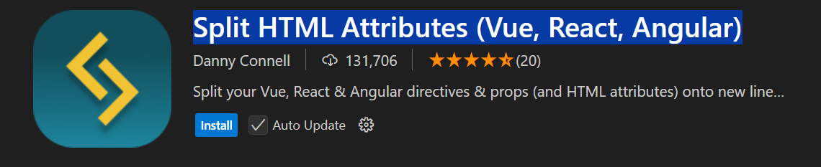

**Select Line Status Bar**

**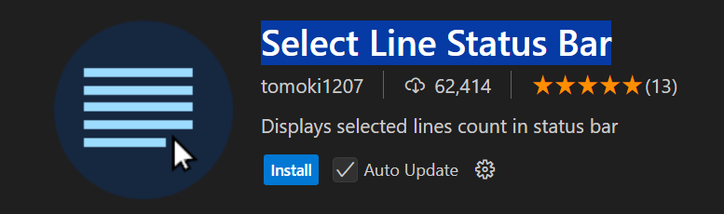  
VS HTML to CSS**

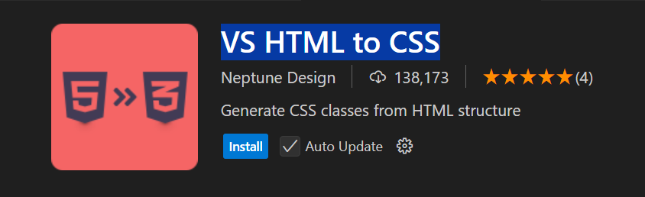

**Line History**

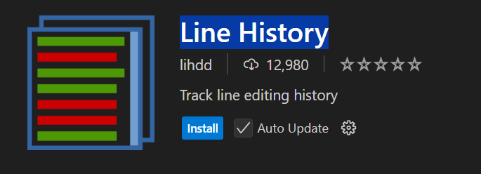

**IntelliSense for CSS class names in HTML**

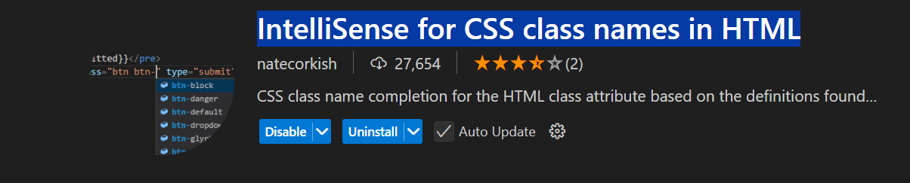

**Tailwind Shades**

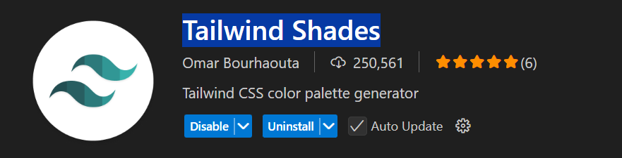

**Tailwind Fold**

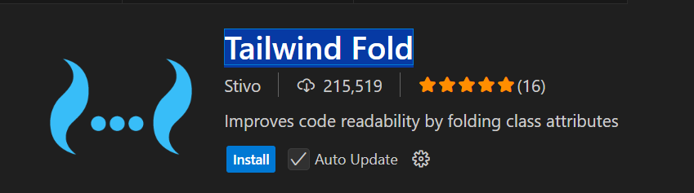

**Color Info**

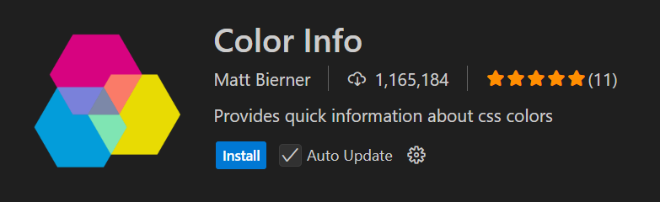

**color conversion**

